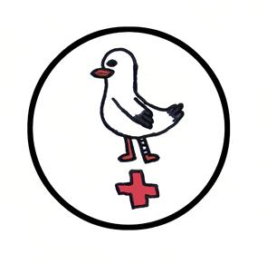
Dr S. Barclay
Dr M. Sinclair
Dr E. Barr
Dr R. Ferguson
Dr C. Jack
Dr K McArthur
Dr J Ledingham

moray coast
medical practice

Zero Tolerance Policy

In line with the NHS zero tolerance guidelines on abuse of patients and staff, this Practice will not tolerate any incidents of violence, aggression and/or rudeness by ANY patients to the Practice Staff and/or patients either physically, verbally or through social media.

In the event of a patient being rude to Practice Staff or to other patients within the Surgery, or by patients using threatening and/or abusive language on the telephone, or posting derogatory remarks on social media, the Practice Manager will be informed.

Continued inappropriate behaviour may result in the patient being removed from the practice list.

